GT Assignment

**About the game-**

This is a concept about an interactive mobile application that’s to visualize and give a virtual experience of tourist attractions in Sri Lanka. And the main concept behind all of this is the rising demand for augmented reality applications and to incorporate that with a way to promote tourism of this country.

This is a wildlife vet game. The player can start the game in level 1. There are many levels. There is a main character in the game. He is a wildlife vet. He has a job doing treatment for injured animals when the signal comes. Sometimes it has become a national park, beachside, zoo-like place. After the signal is received, the vet must go and treat the injured animals. The track is seen on the map where the vet will go. The players get time to complete the mission. In that time the player must be completed their service. Can enter the virtual 360 degree preview of the player if player want.

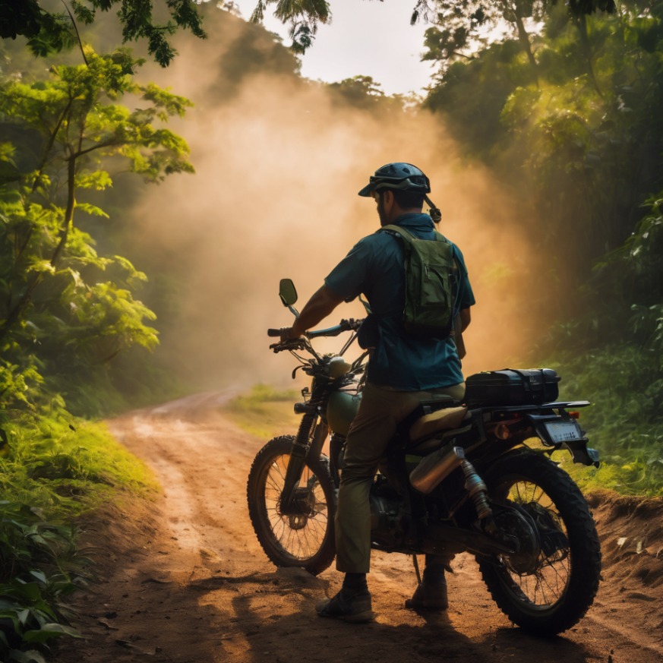

**How your game would promote tourism?**

Create a virtual world or environment that closely close to the actual real world. Players can see the virtual version of the place, which might include landmarks, natural wonders, and cultural attractions. In that virtual exploration, players will think they want to visit real things and make them want to see the real thing.

Develop game levels, to level to level have new tracks and players can see traveling to different destination. As players progress through the game, they learn about the history, culture, and traditions of the place. This can spark curiosity and motivate players to experience it firsthand.

The game should be both entertaining and informative, teaching players about wildlife conservation and the challenges faced by wildlife vet.

After playing the game players have ideas about the national parks and visit various places within the game. It includes traditional places, then when they are playing the game. Sometimes they want to visit and get experience in real like the game. In that, Sri Lanka tourism can be promoted. There are traditional temples, popular places can be seen on both sides road.

**How culturally appropriate your game is going to be**

Where the game is played from level to level there are places in the local cultures and traditions of the region and religions. Understand the values, beliefs, and customs of the local communities to the players. There are cultural things and places in Sri Lanka seen on both sides of the roads. In that players get good ideas about cultural things.

All the cultural places are displayed and presented the details if players want to know about them.

By including language options and cultural references, the players can get an idea about the cultural environment. Conduct thorough play testing with players from different cultural backgrounds to identify and address any cultural issues that may arise during gameplay.

Represent a diverse range of cultures and backgrounds in the game's characters, especially if the game is set in a global context. Represent a diverse range of backgrounds and cultures in the game's characters, especially if the game is set in a global context.

Show the cultural events like a back story before starting the game. In that players or audiences can think about the Sri Lanka cultural programs.

**Which devices are you going to publish the game for?**

Pc, Laptop (mac, Windows)

Mobiles (IOS, Android)

Xbox

Play Station

Nintendo Switch

**Who is your target audience?**

The target audience for this application would be everyone starting with anyone that could learn visually. Being able to read and comprehend is not compulsory. In short, the target audience will be anyone that’s at least 3 years old who’s living in and out of the country and wants to learn about Sri Lanka, its culture and heritage.

Games often cater to specific age ranges, such as children, teenagers, adults, or seniors. The age of the target audience can influence the complexity of the game, its themes, and its visual style.

All Foreign people, all teenagers and children in the world within Sri Lanka open for that experience. If should play this virtual game and they can get idea about the Sri Lankan culture, religion and traditional events.

In the changing world, all humans like walking and feel various natures and get various activities. Since until the game design, developer can design like that points.

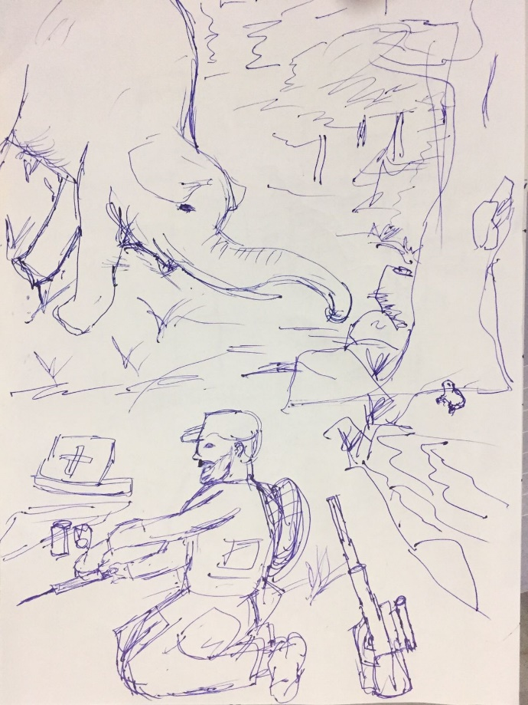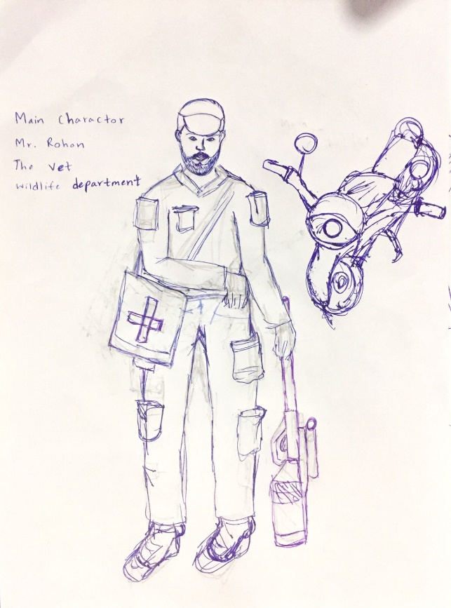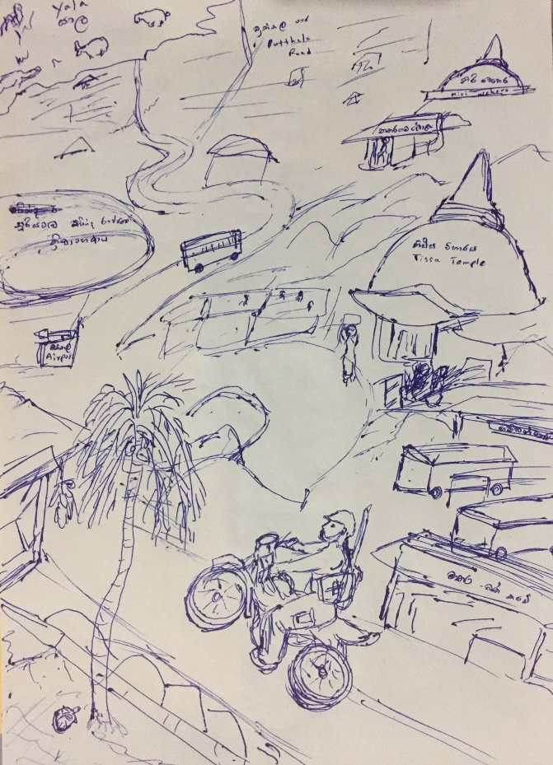**Concept art**

